1. Which are the top three variables in your model which contribute most towards the probability of a lead getting converted?

Lead Scoring Subjective Questions

**Solution: -** As per regression model we have find the below top 3 Features which are the having highest coefficient that indicates the hot lead

* + 1. **TimeSpent**
    2. **NotableActivity_Had a Phone Conversation**
    3. **Lead Origin_Lead Add Form**

**Given are the Top and Bottom feature graph:-**

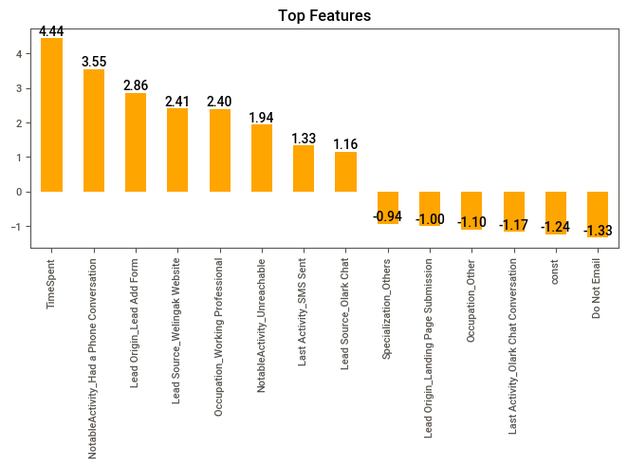

1. What are the top 3 categorical/dummy variables in the model which should be focused the most on in order to increase the probability of lead conversion?

**Solution: -** Company should focus on the given top 3 Features which can be significant lead conversion.

* + 1. **TimeSpent**
    2. **NotableActivity_Had a Phone Conversation**
    3. **Lead Origin_Lead Add Form**

1. X Education has a period of 2 months every year during which they hire some interns. The sales team, in particular, has around 10 interns allotted to them. So during this phase, they wish to make the lead conversion more aggressive. So they want almost all of the potential leads (i.e. the customers who have been predicted as 1 by the model) to be converted and hence, want to make phone calls to as much of such people as possible. Suggest a good strategy they should employ at this stage.

**Solution: -** Company should focus on hot lead first to make a call as much as possible to the given below features customers as per analysis these category customers have high lead conversion rate. Also, Company should focus on other features as well who is mostly visited and spent the time

* + 1. **Unemployed -** As per analysis we have find the high conversion rate in this category
    2. **Do Not Email -** Lead conversion for the Client who has asked for mail is highest conversion rate hence intern should also focus on this feature clients
    3. **SMS Sent –** As per analysis we have identify the conversion rate of SMS sent is significant high so company should focus on this feature as well.
    4. **Specialization -** Finance, HR and Marketing Specialization features have high chances of lead conversion hence company should call on this feature.

1. Similarly, at times, the company reaches its target for a quarter before the deadline. During this time, the company wants the sales team to focus on some new work as well. So during this time, the company’s aim is to not make phone calls unless it’s extremely necessary, i.e. they want to minimize the rate of useless phone calls. Suggest a strategy they should employ at this stage.

**Solution: -** To minimize the rate of useless phone calls, Company should avoid connecting with the low probability conversion customers and focus on most hot leads who has shown the interest in taking the products.

To avoid the phone call and as we have seen there are high conversion in SMS and Email as well hence company should focus on these customers.

Since company has reaches the target company should start working on the strategy of marketing through online and offline by advertising or emailing.

Also sales team should analyse the customer which is low chances and research and find out the customer requirements and make a call with fully prepared.

In this time company should also focus on the sales team for their training of on the products knowledge and understanding the customer needs.

Company should implement all the above strategy to avoid useless phone calls during the quarter and also focus on more effective methods to lead conversion.

*********************************************************************************************

Thanks and Regards,

Mohd Sami Uzzaman / Agney Ravi O / Aditi Mishra